**AWS LAMBDA**

1. **I have Created one Instance Initially (Stop). By using Lambda I need to start the Instance.**

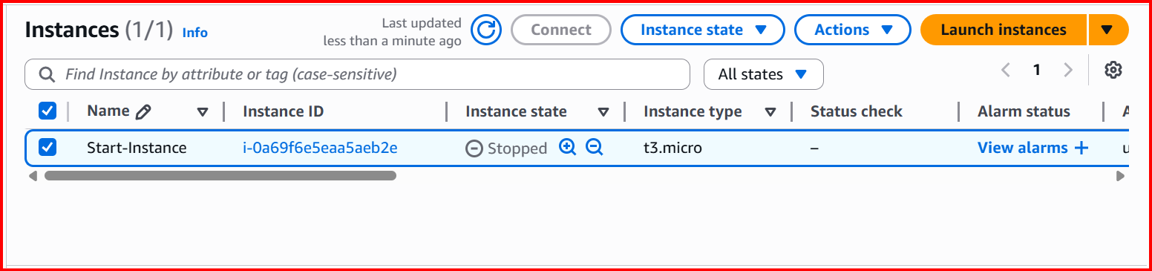

**Create Lambda Function**

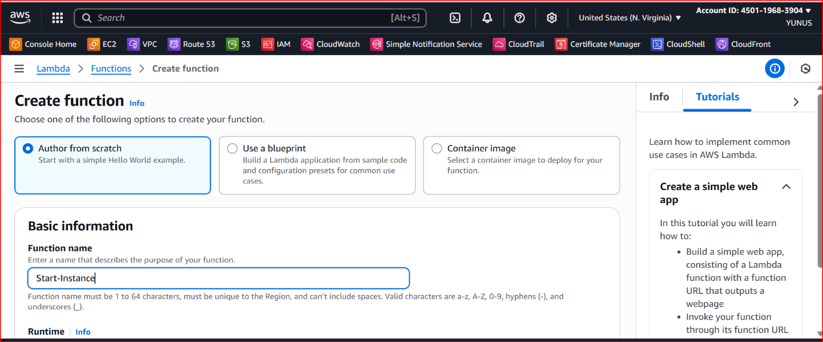

**Choose the Runtime (Python)**

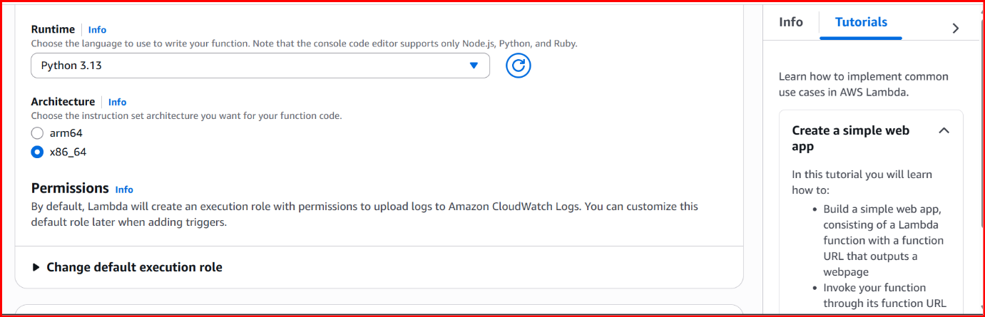

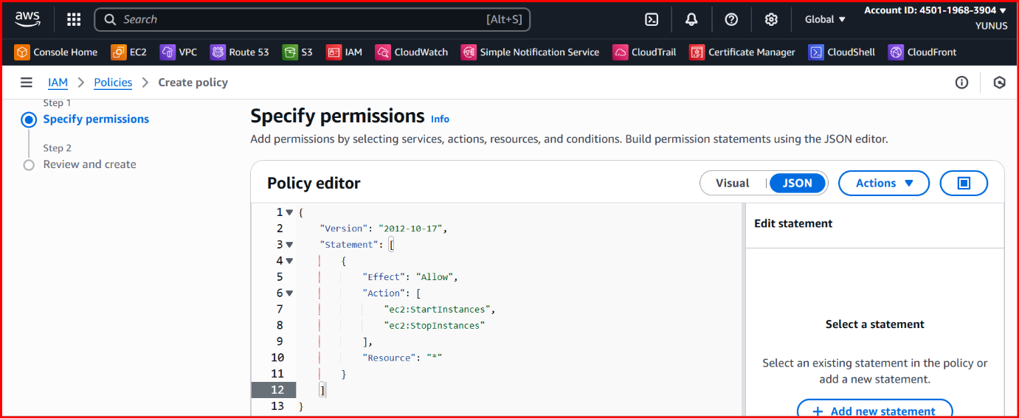

**Create a Role**

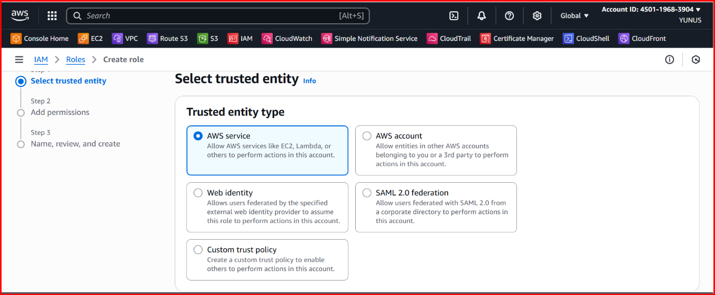

**Choose Lambda**

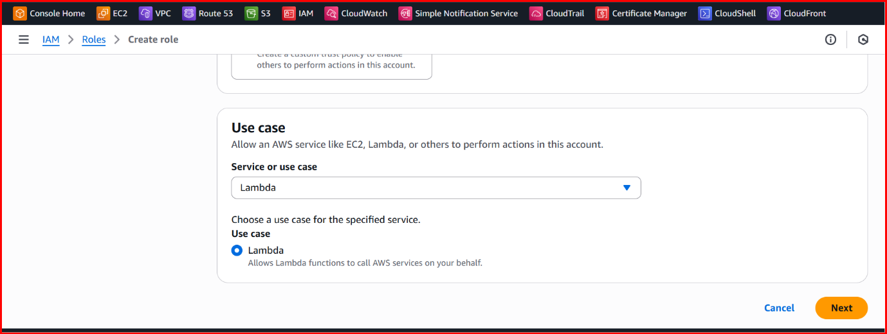

**In roles add permissions which we have created before.**

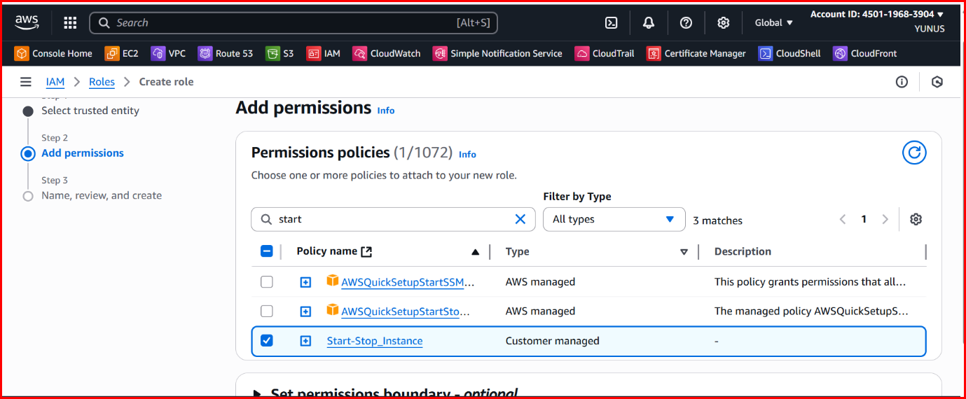

**In lambda function (choose the existing role) and add the created role.**

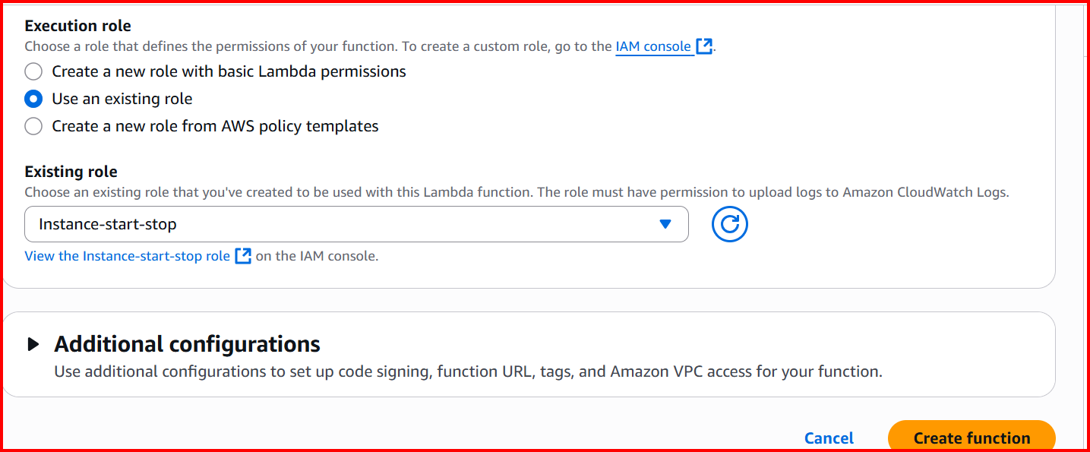

**Create function.**

**In lambda functions check function is created or not**

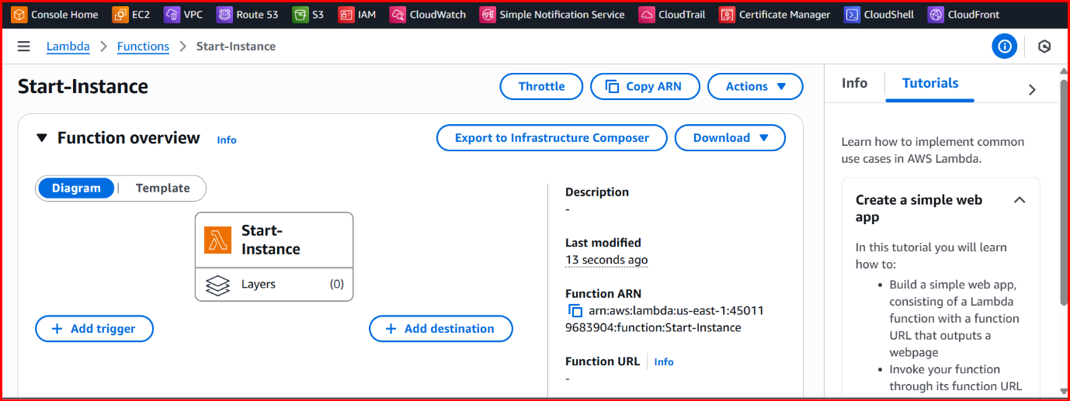

**Just below**

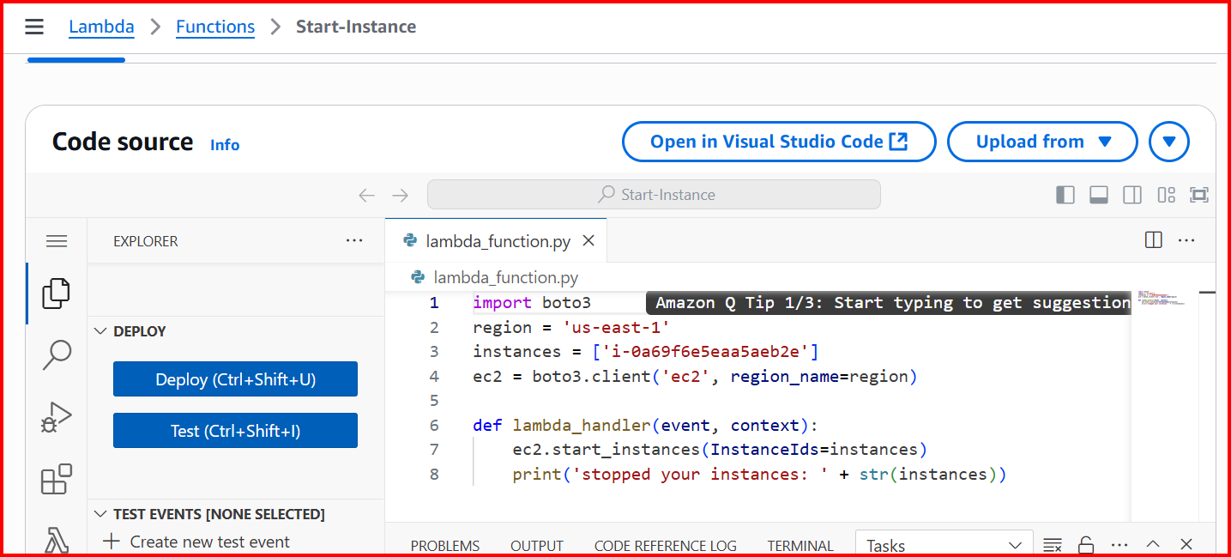

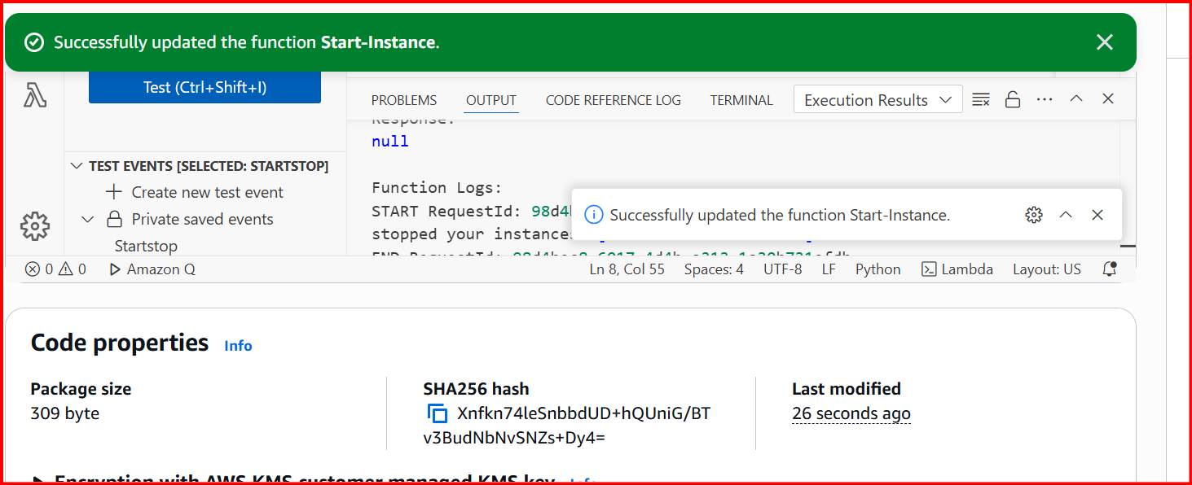

**After that trigger one event**

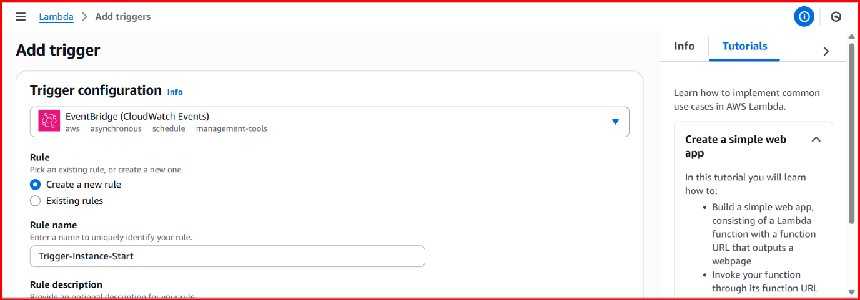

**Schedule the time (According to the it will start)**

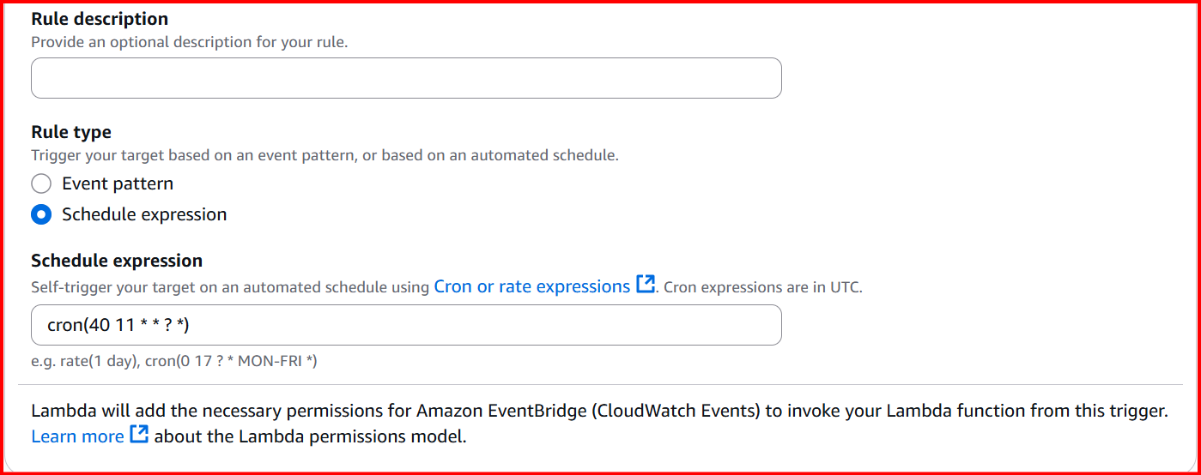

**Once Event has been created it will look like this**

